8. PO/Requisition Menu: R. Reports Menu: 6. Purchase Order Inquiry

Table of Contents
Purchase Order Inquiry 3
Single PO 4
Post for a Vendor 5

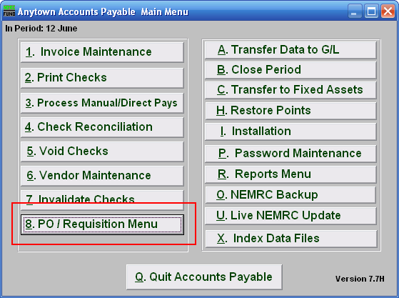
Click on “8. PO / Requisition Menu” from the Main Menu and the following window will appear:

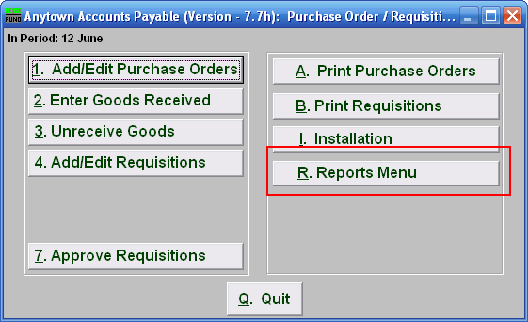
Click on “R. Reports Menu” from the Purchase Order / Requisition Menu and the following window will appear:

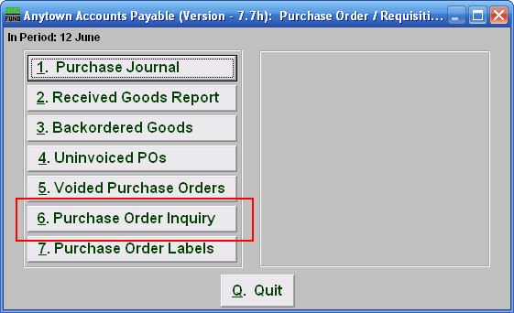
Click on “6.Purchase Order Inquiry” from the Purchase Order / Requisition’s Reports Menu and the following window will appear:

Purchase Order Inquiry

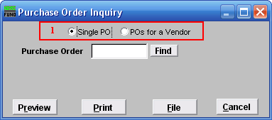
- Single PO OR POs for a Vendor: Choose if you are searching for a Single Purchase Order or if you are searching for Purchase Orders for a Vendor. Refer to the section below that relates to your choice.

Single PO

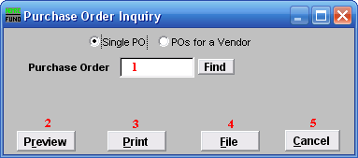
- Purchase Order: Type in the Purchase Order number you are looking for OR click “Find” and select from there.

- Preview: Click this button to preview the report. Refer to GENERAL PREVIEW for more information.

- Print: Click this button to print this report. Refer to GENERAL PRINT for more information.

- File: Click this button to save this report on this computer. Refer to GENERAL FILE for more information.

- Cancel: Click “Cancel” to cancel and return to the previous screen.

Post for a Vendor

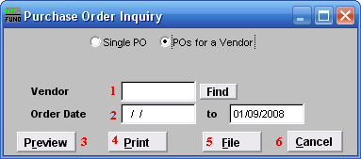
- Vendor: Type in the Vendor Code OR click “Find” and select from there.

- Order Date: Enter the Order Dates you wish to search in. Leaving the start date blank will be treated as all purchased orders up to the ending date provided

- Preview: Click this button to preview this report. Refer to GENERAL PREVIEW for more information.

- Print: Click this button to print this report. Refer to GENERAL PRINTING for more information.

- File: Click this button to save this report on this computer. Refer to GENERAL FILE for more information.

- Cancel: Click “Cancel” to cancel and return to the previous screen.

